ADDB7311

ICE Task 2 – Synonyms, Views, Indexes Pg 74

ST10305921 – Zoe Heyneke

* Create tables

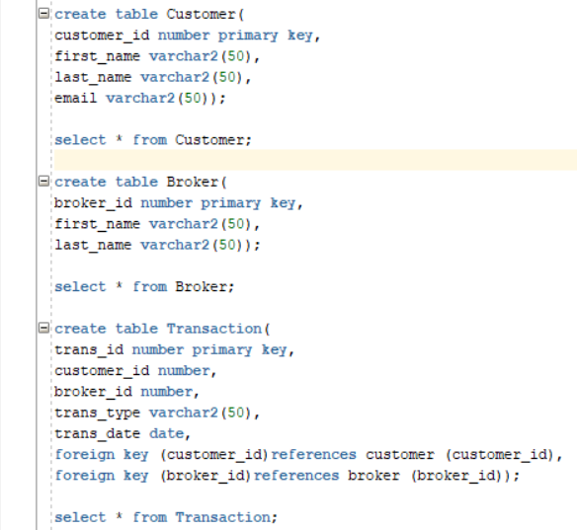

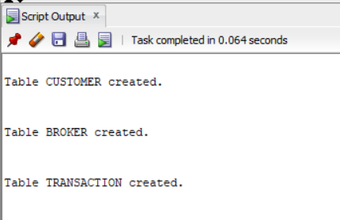

create table Customer(

customer_id number primary key,

first_name varchar2(50),

last_name varchar2(50),

email varchar2(50));

select * from Customer;

create table Broker(

broker_id number primary key,

first_name varchar2(50),

last_name varchar2(50));

select * from Broker;

create table Transaction(

trans_id number primary key,

customer_id number,

broker_id number,

trans_type varchar2(50),

trans_date date,

foreign key (customer_id)references customer (customer_id),

foreign key (broker_id)references broker (broker_id));

select * from Transaction;

* Create sequence called sales_id starting at ID 560

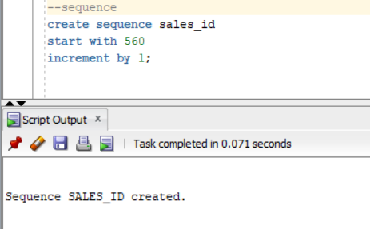



--sequence

create sequence sales_id

start with 560

increment by 1;

* Create view called Transaction_Details displaying customer ID, broker ID, transaction type and transaction date between 22 March 2019 and 25 March 209

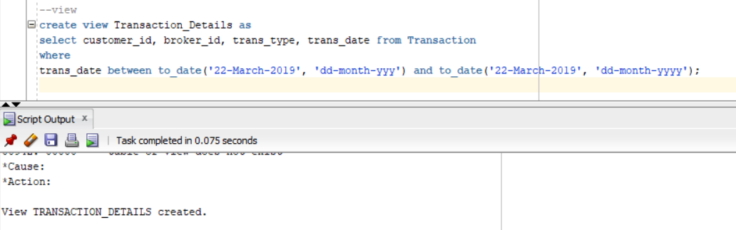

--view

create view Transaction_Details as

select customer_id, broker_id, trans_type, trans_date from Transaction

where

trans_date between to_date('22-March-2019', 'dd-month-yyy') and to_date('22-March-2019', 'dd-month-yyyy');

* Create Synonym for Broker table called Bro

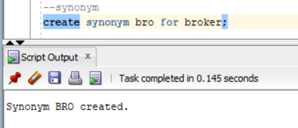

--synonym

create synonym bro for broker;

* Create index on Customer table for the first_name column

--index

--purpose to reduce access time

create index in_customer_first_name on Customer(first_name);